REST API Introduction

Introduction

What is a REST API ?
Let’s say you’re trying to find Batman videos on Youtube. You open up Youtube, type “Batman” into the search field, hit enter, and you see a list of videos about Batman. A REST API works in a similar way. You search for something and you get a list of results back from the service you’re requesting it from.

API: Application Programming Interface
It is a set of rules that allows programs to talk to each other. The developer creates the API on the server and allows the client to talk to it.

REST: REpresentational State Transfer
Determines how the API looks like. It is a set of rules that developers follow when they create their API. One of these rules states that you should be able to get a piece of data (called a resource) when you link to a specific URL.

Additional Resources
#RESTful API
https://www.techtarget.com/searchapparchitecture/definition/RESTful-API

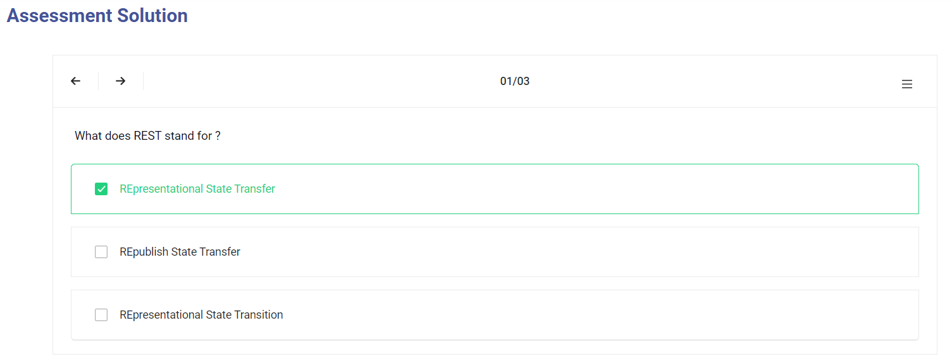

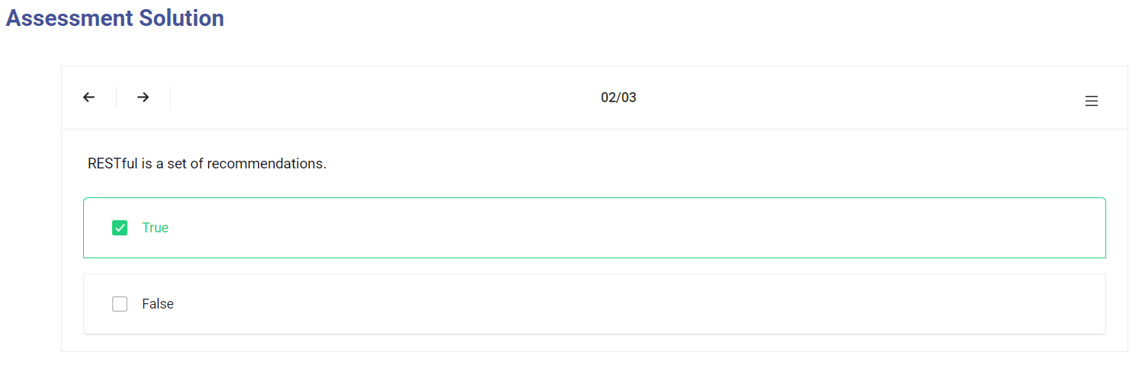
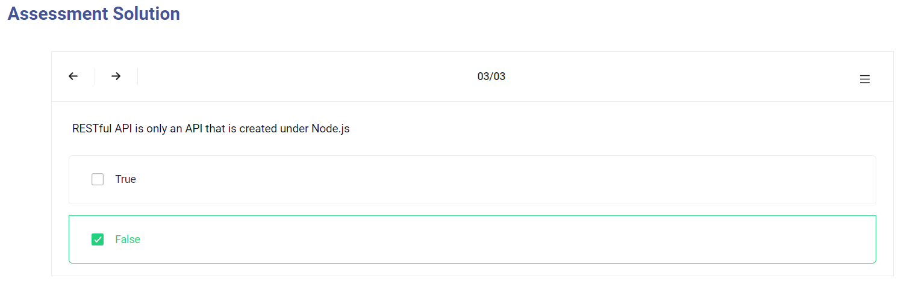

Request

Request
The internet boasts a vast array of resources hosted on different servers. For you to access these resources, your browser needs to be able to send a request to the servers and display the resources for you. HTTP (Hypertext Transfer Protocol) is the underlying format that is used to structure requests and responses for effective client-server communication. The message that is sent by a client to a server is what is known as an HTTP request. Clients can use various methods to send requests to a server.
Therefore, HTTP request methods are the assets that indicate the specific desired action to be performed on a given resource. Each method implements a distinct semantic, but there are some standard features that are shared by the various HTTP request methods.
To test HTTP requests, we can use softwares like Postman

Additional Resources
#HTTP request
https://www.tutorialspoint.com/http/http_requests.htm

https://www.postman.com/

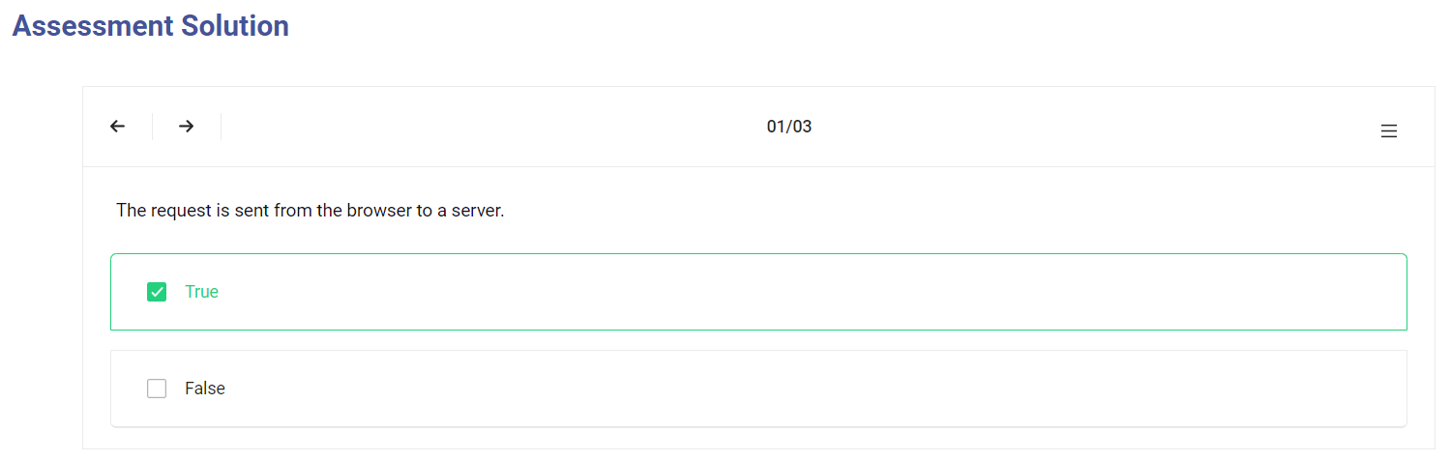
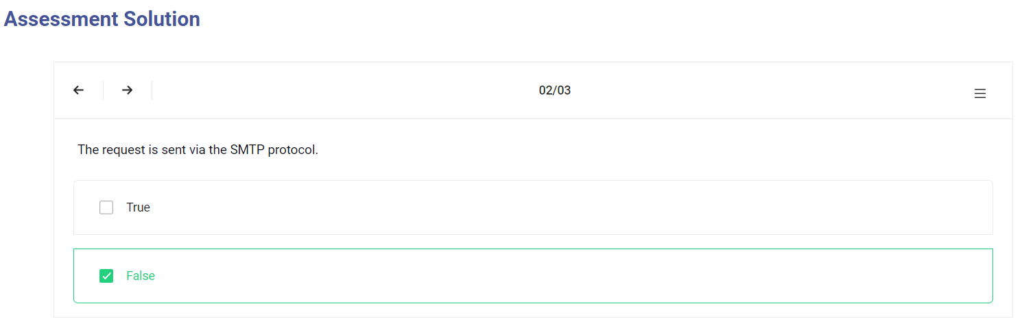
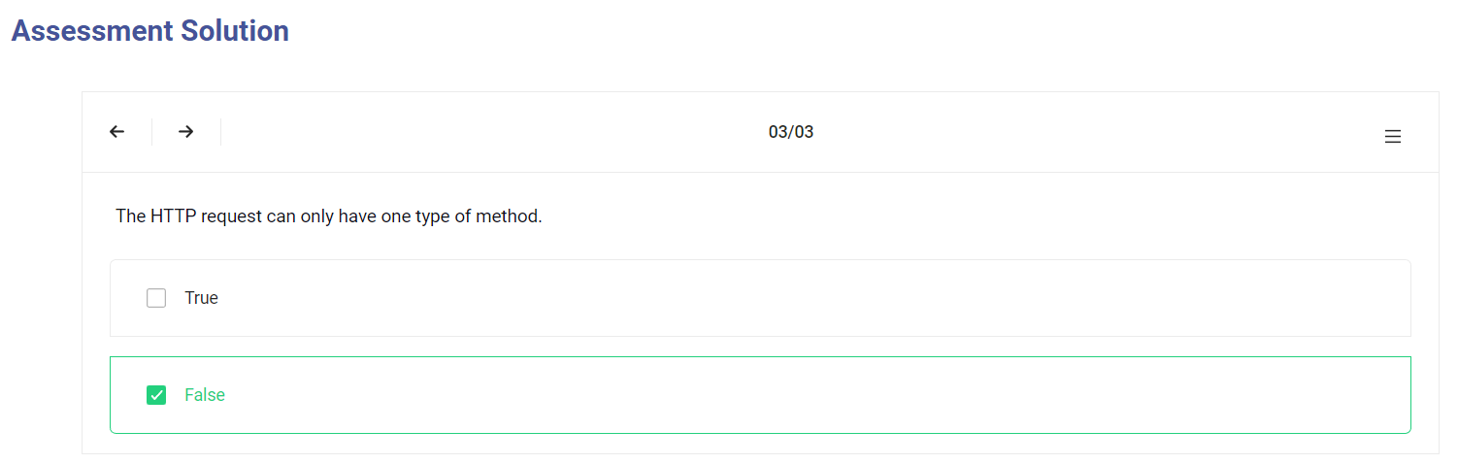

Request Headers

Request Headers

Headers are used to provide information to both the client and the server. It can be used for many purposes, such as authentication and providing information about the body content.
Example of a HTTP Request Headers:
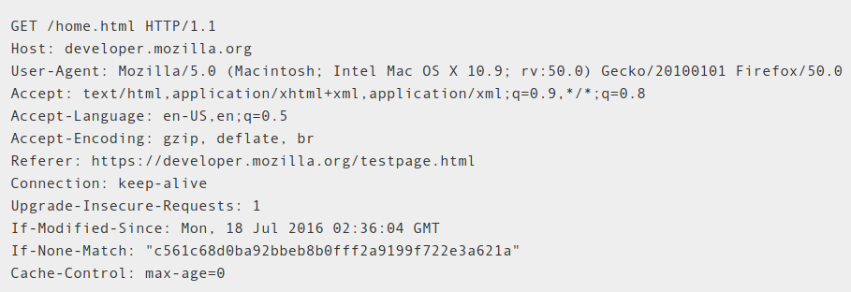

Additional Resources

Additional Resources
#Headers fields
https://en.wikipedia.org/wiki/List_of_HTTP_header_fields

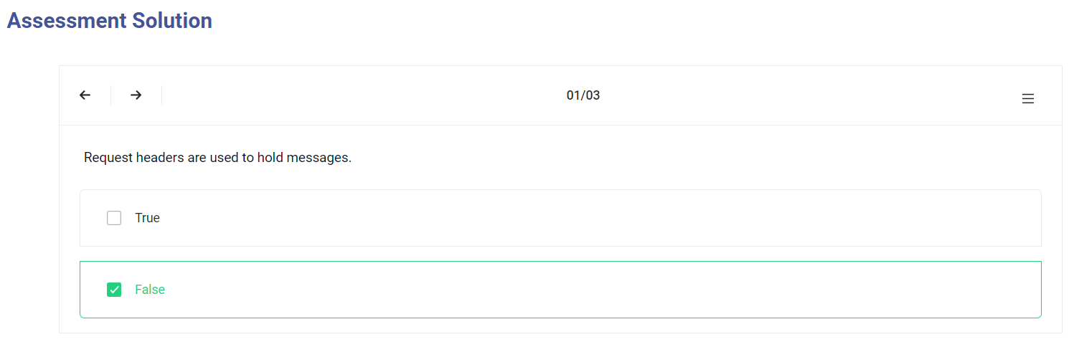

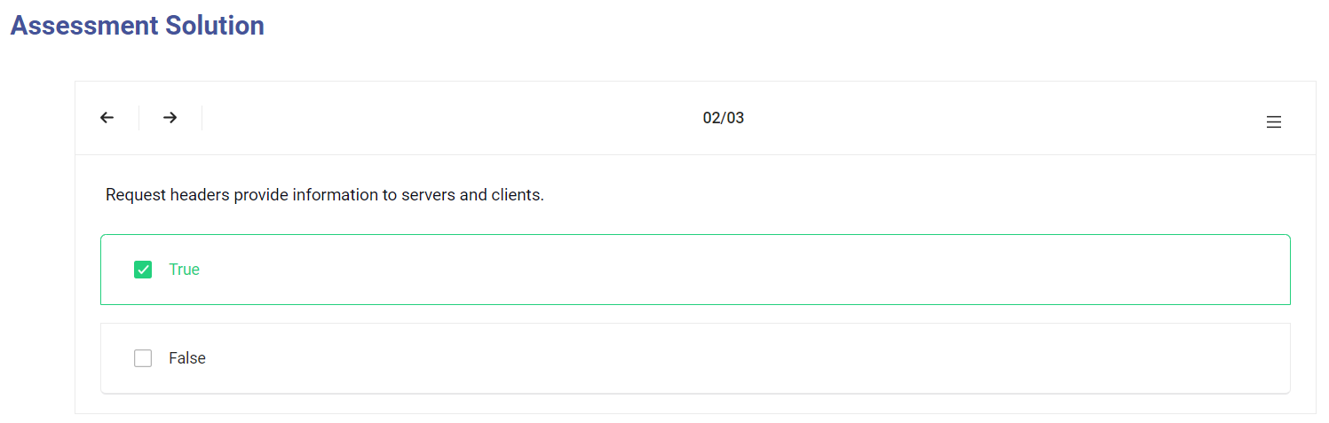
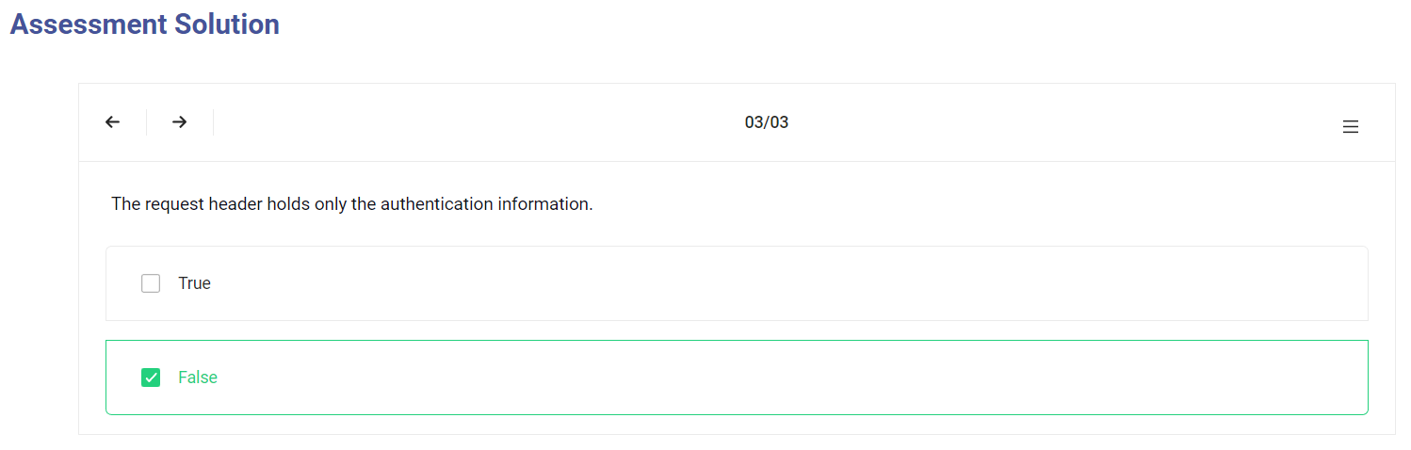

Request Body

Request Body

The body (sometimes called “data” or “message”) contains information you want to be sent to the server. This option is only used with POST, PUT or DELETE requests.
For a sign in request, a body example can be the email and password.
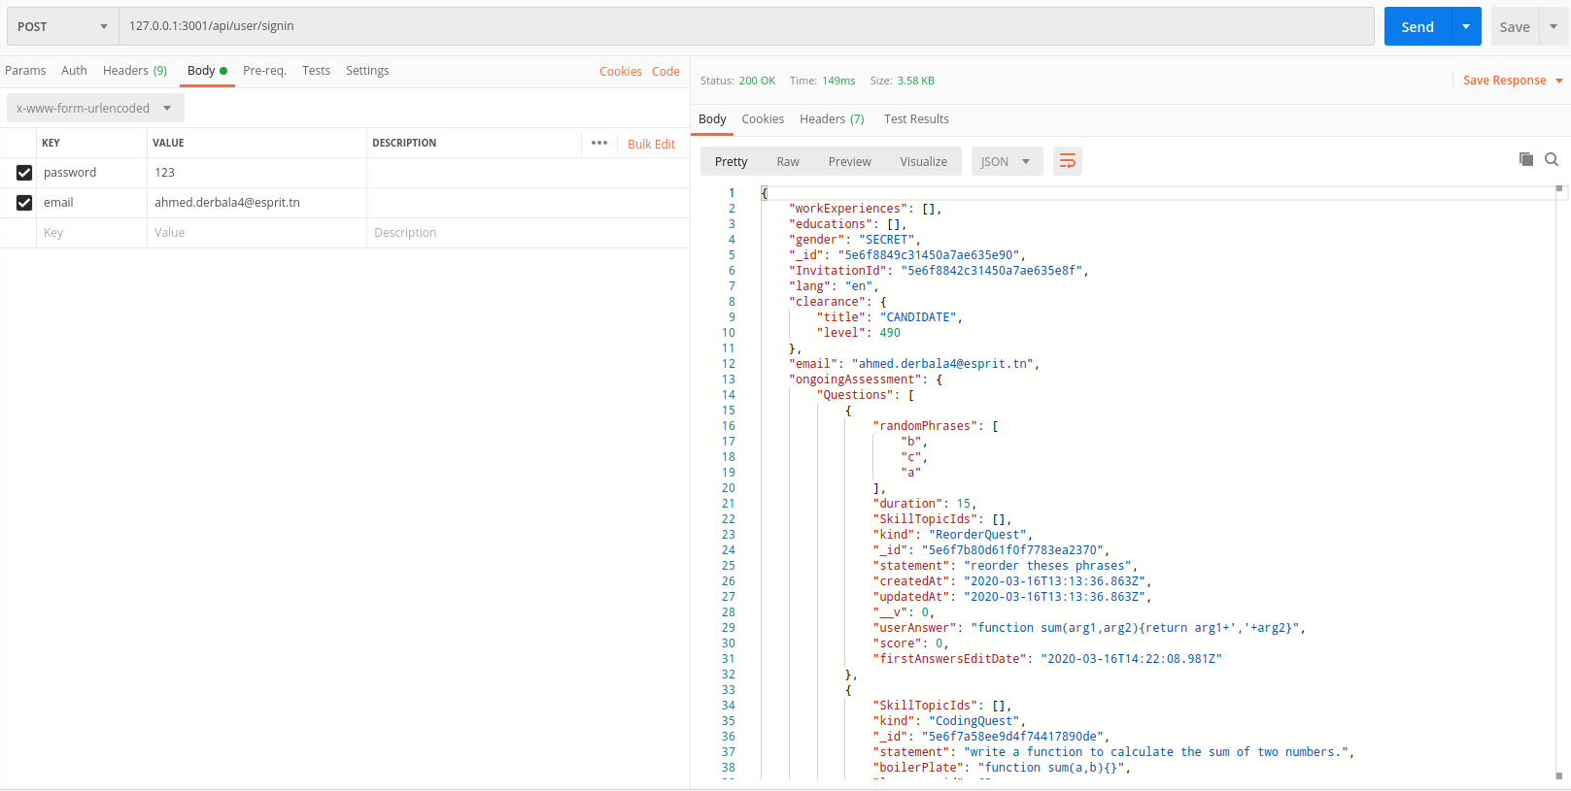

Additional Resources
#Request body
https://www.toolsqa.com/client-server/http-request/

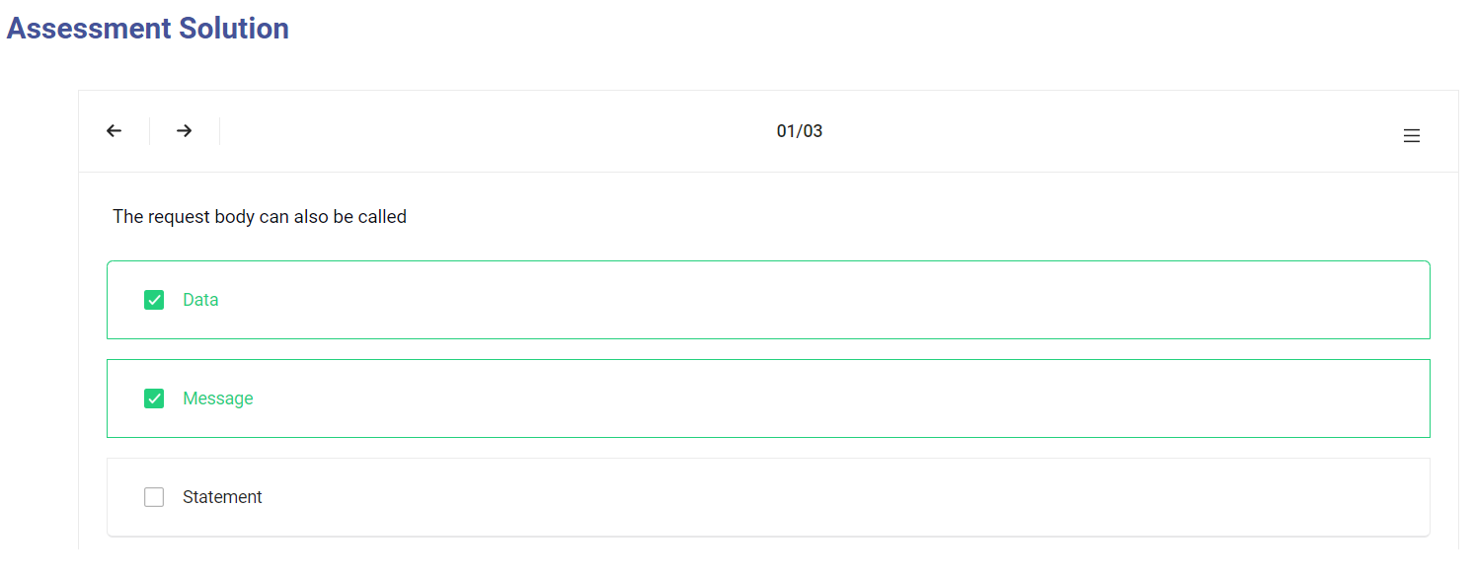
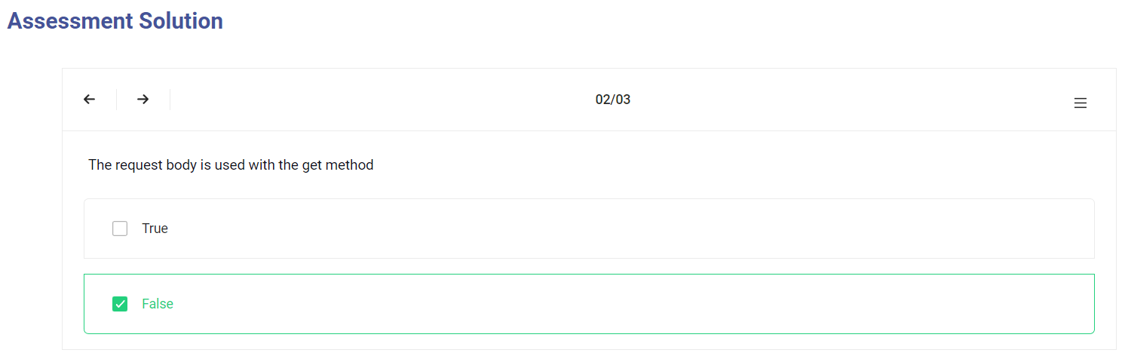
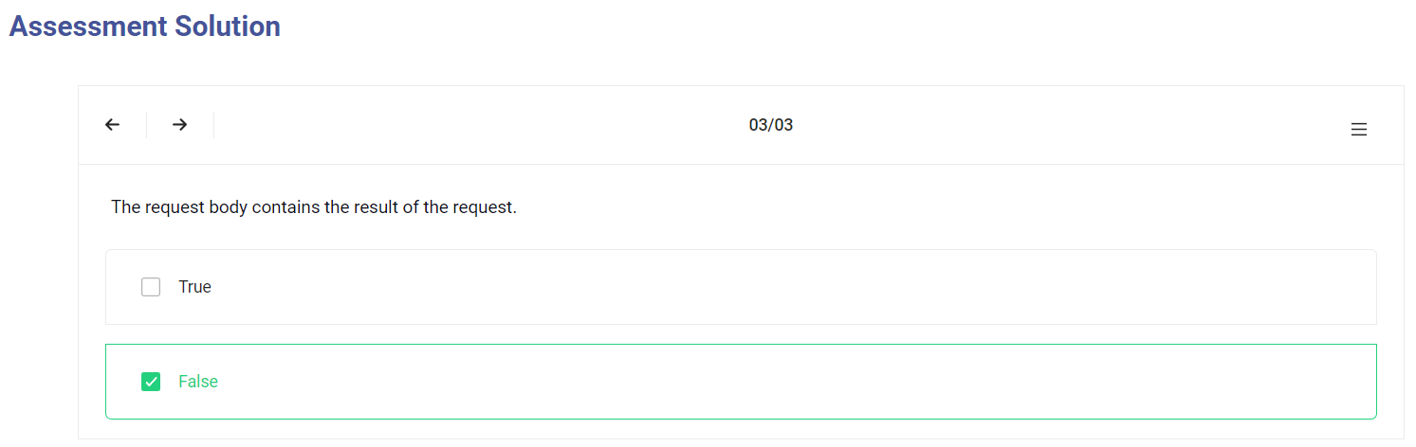

HTTP Response

HTTP Response

When a client (browser) makes a request to a server, the server responds with a reply including a status code.
HTTP response status codes indicate whether a specific HTTP request has been successfully completed. Responses are grouped in five classes:
Informational responses (100–199),
Successful responses (200–299),
Redirects (300–399),
Client errors (400–499),
and Server errors (500–599).


Additional Resources
#List of HTTP status codes#HTTP response

https://en.wikipedia.org/wiki/List_of_HTTP_status_codes
https://www.tutorialspoint.com/http/http_responses.htm

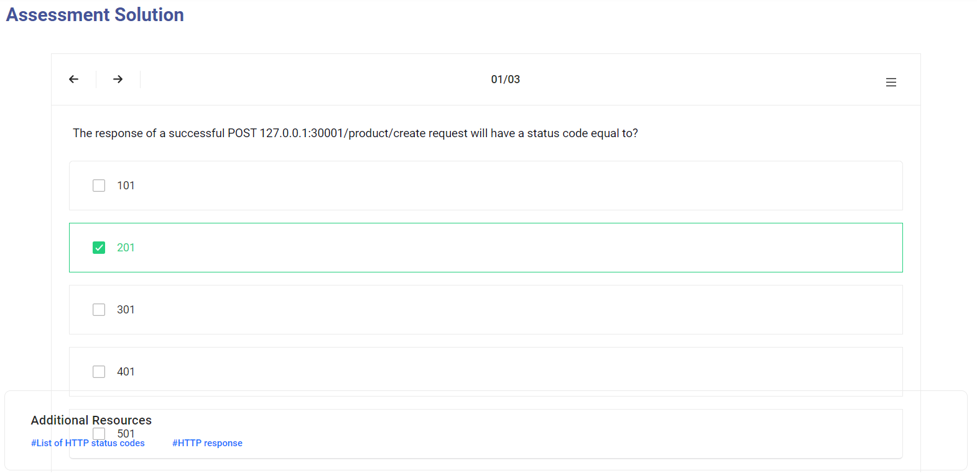
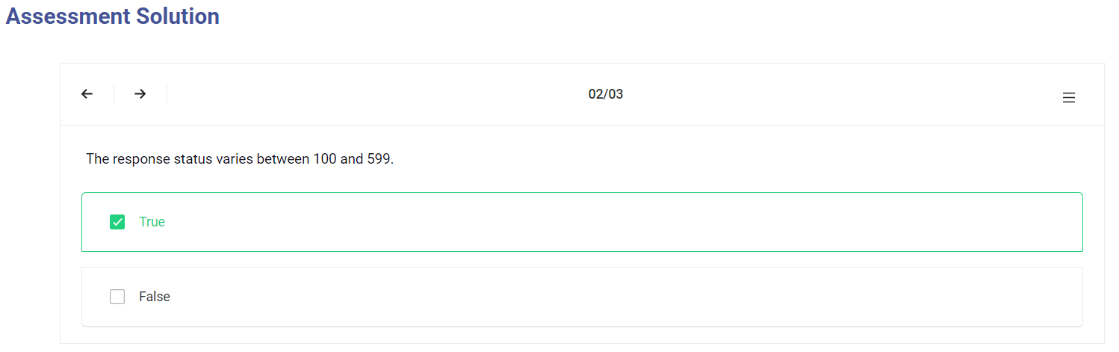
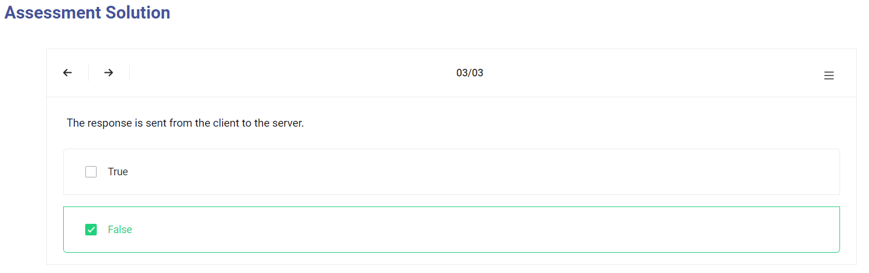

POST Method

POST Method

This request is used to create a new resource on a server. If you perform a POST request, the server creates a new entry in the database and tells you whether the creation is successful or not. In other words, a POST request performs an CREATE operation.

Additional Resources
#POST Data

https://www.codegrepper.com/code-examples/delphi/javascript+post+to+url

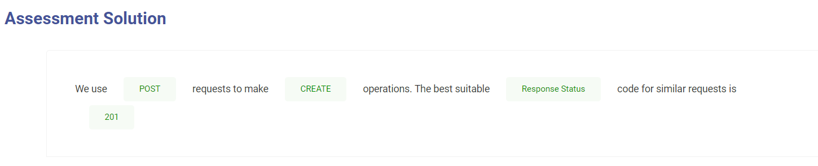

GET Method

GET Method

This method is used to get a resource from a server. If you perform a GET request, the server looks for the data you requested and sends it back to you. In other words, a GET request performs a READ operation. This is the default request method.
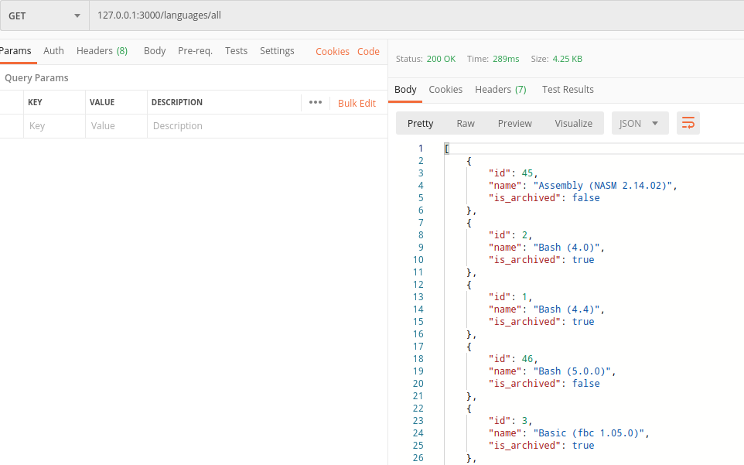

Additional Resources
#GET method
https://rapidapi.com/blog/api-glossary/get/

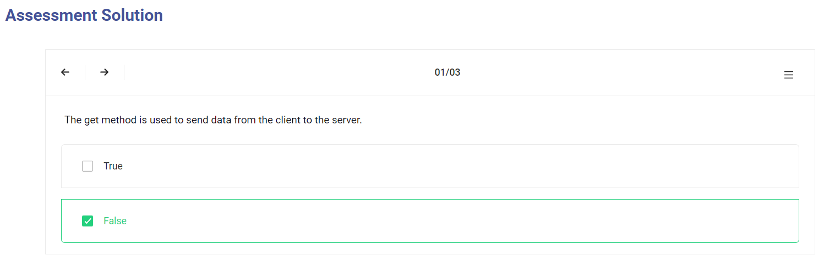
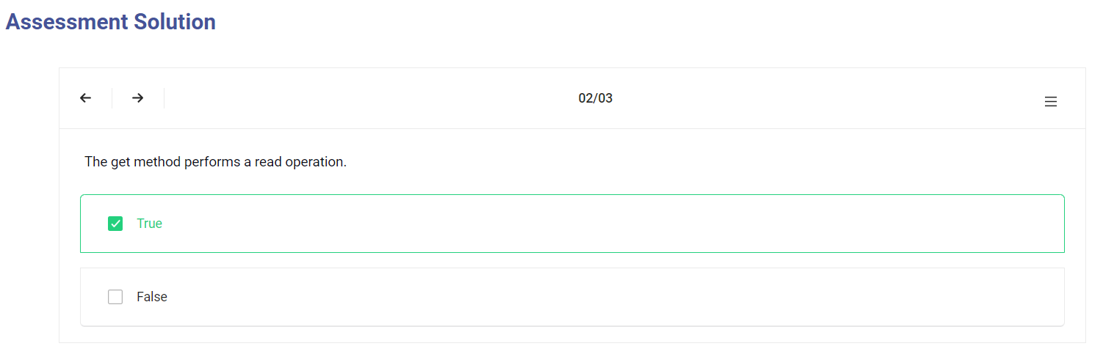
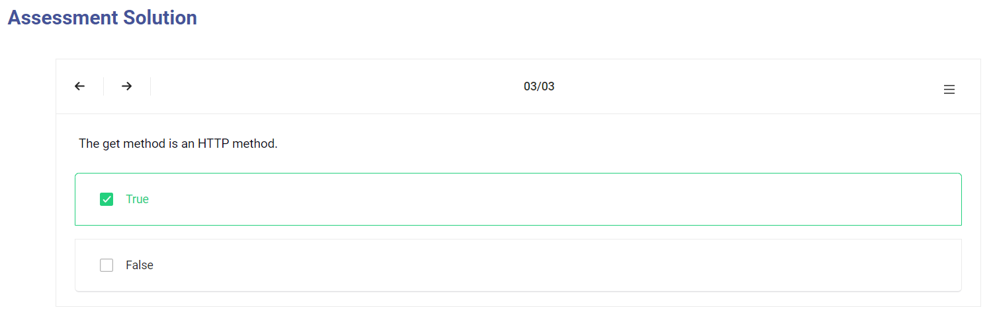

PUT Method

PUT Method

This request is used to update a resource on a server. If you perform a PUT request, the server updates an entry in the database and tells you whether the update is successful or not. In other words, a PUT request performs an UPDATE operation.
When sending a PUT request, we add a body containing the modification to be performed.

Additional Resources
#PUT method

https://rahmanfadhil.com/express-rest-api/

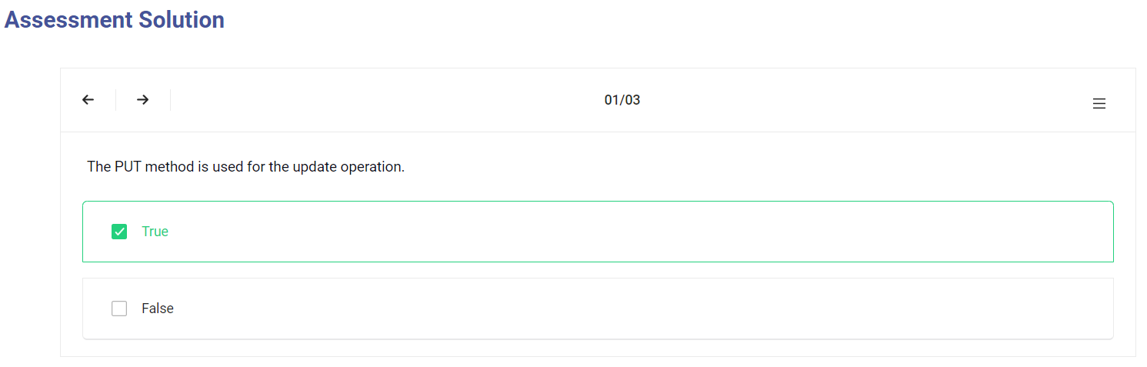
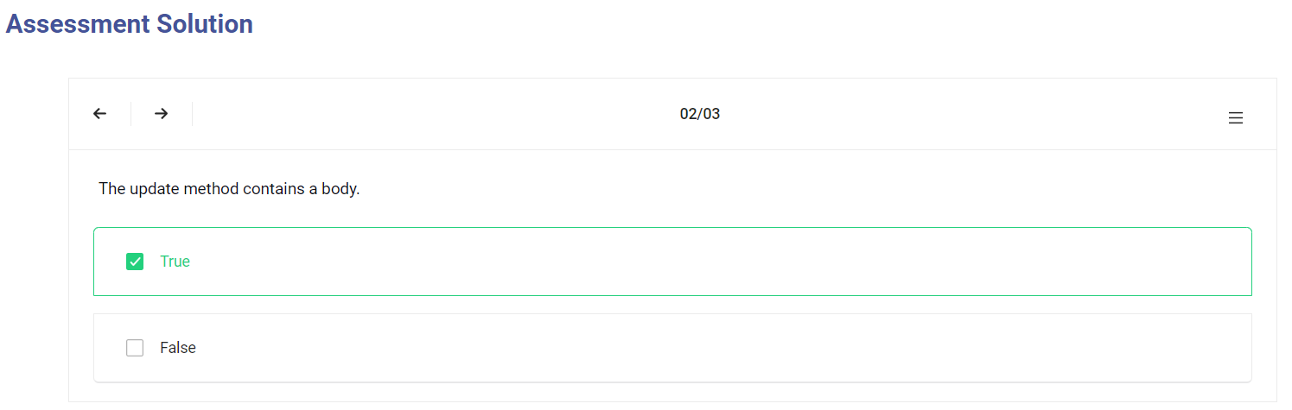
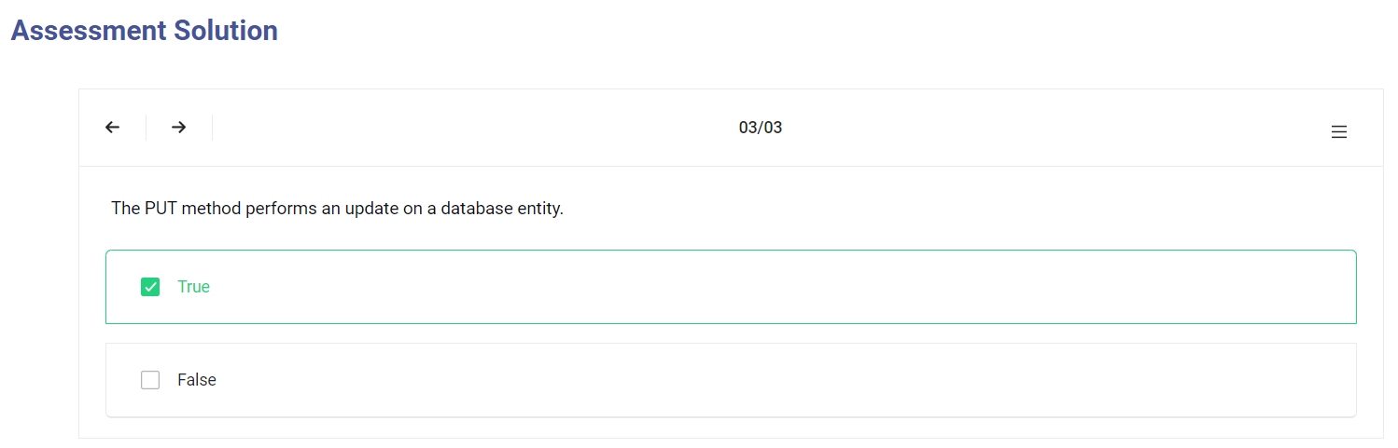

DELETE Method

DELETE Method

This request is used to delete a resource from a server. If you perform a DELETE request, the server deletes an entry in the database and tells you whether the deletion is successful or not. In other words, a DELETE request performs a DELETE operation.

Additional Resources
#Delete method
https://coursework.vschool.io/mongoose-crud/

